# CSD221 Lab 3 W19

### Assignment: Implement the Book, DiscMag, Magazine and Publication classes from chapter 3.

(implement the following UML from the lecture note)

NOTE** put your source code in a package called lab3

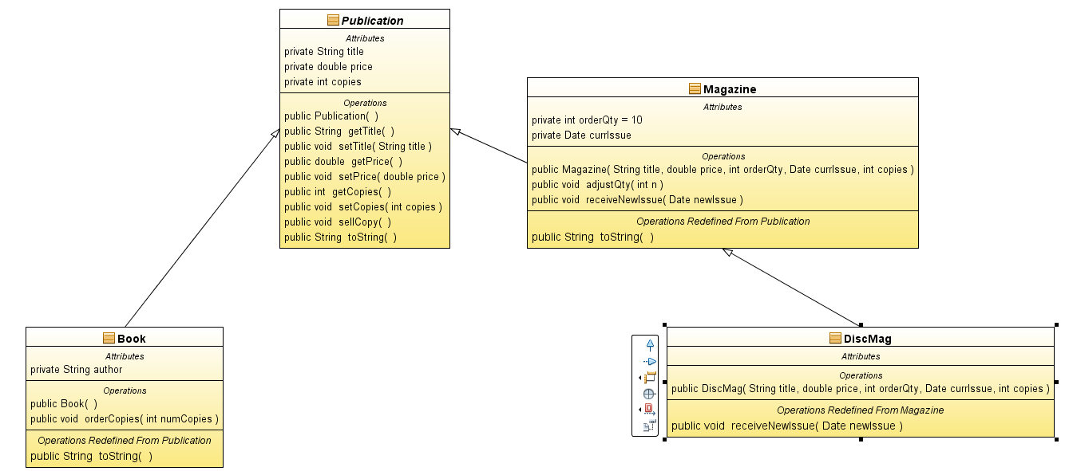

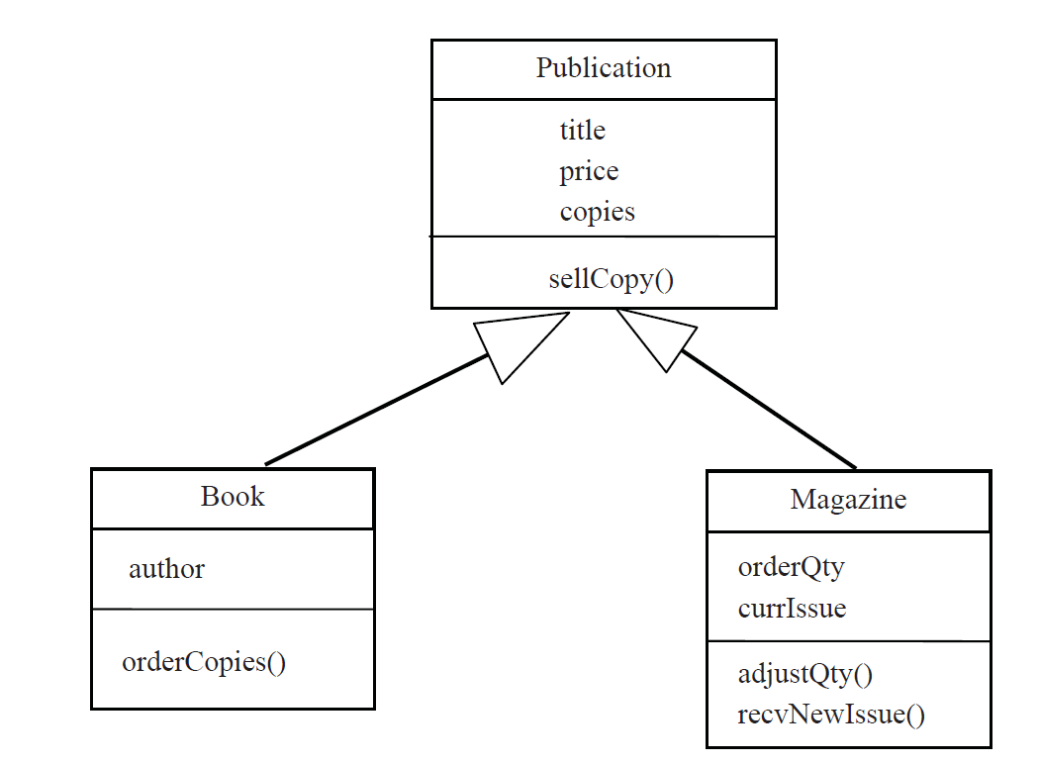

|  |
| --- |
| **TODO 1**:  Create the UML diagram above in Lucidchart. Include the diagram in your source code in a package called “lab3.documentation”  **TODO 2**:  Implement a CRUD (Create/Update/Delete) interface (see below) that will allow you to   * view, * add, * edit and * delete Books.   **NOTE**  structure your app using the app skeleton from the CSD211 Intro to Java course.**  **TODO 3**:  Push your code to git.  **TODO 4:**  Create and upload the UML diagram to your dropbox  **Implement the following menu interface.**  -------------------------Books---------------------------------  1. To Kill a Mockingbird  2. Da Vinci Code  -------------------------------------------------------------------  3. Add a Book  4. Edit a Book.  5. Delete a Book  6. Quit  3  ---------------Add a Book--------------------------  Enter Author ('q' to quit):  Harper Lee  Quantity to Order:  10  Title:  To Kill a Mockingbird  Price:  15.99  ---------------Add a Book--------------------------  Enter Author ('q' to quit):  Dan Brown  Quantity to Order:  20  Title:  Da Vinci Code  Price:  25.99  ---------------Add a Book--------------------------  Enter Author ('q' to quit):  q  -------------------------Books---------------------------------  1. To Kill a Mockingbird  2. Da Vinci Code  -------------------------------------------------------------------  3. Add a Book  4. Edit a Book.  5. Delete a Book  6. Quit  6  Bye... |